GETTING STARTED WITH RELIAS
To connect/load the Relias application you have several options. From any internet connected computer:
- From HOME: Open a browser (Internet Explorer(IE), Chrome, Firefox or Safari) and type or click on the following address: transitionslifecarehovo.training.reliaslearning.com
OR
- From the TL OFFICE: Go to the H drive and click on the Relias shortcut icon

To log in, your user id will be your email address. Your password will be “password” unless you change it.

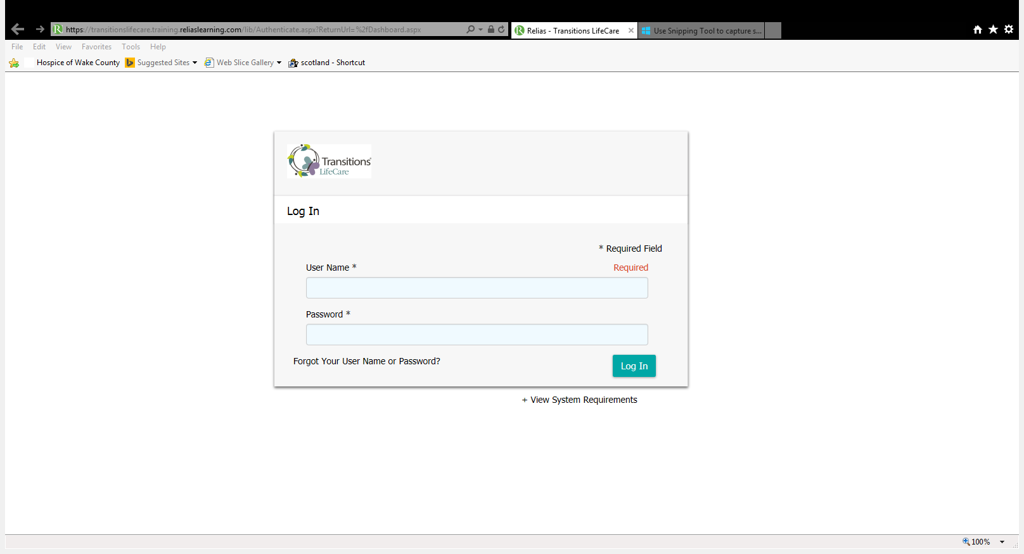
joesmith@hotmail.com
password

The first time you login you will be asked to select three security questions. This is the only time you will see that screen.
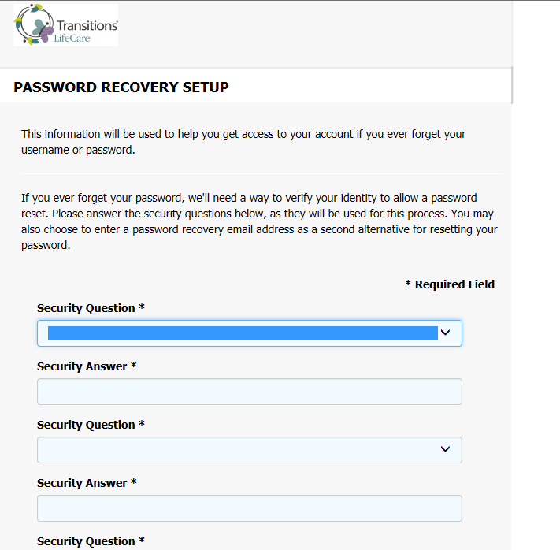

Once you login you will see a screen similar to the following. This is your “My Learning / Current Training” page and it will show you any courses that you have been enrolled in by either the Volunteer Department, the Education Department or that you have self-enrolled in.
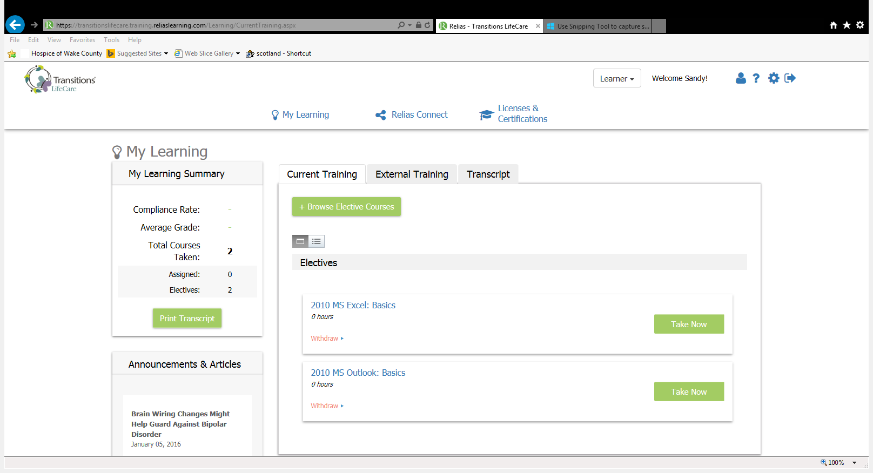

If there is a due date for completion you will see it here:
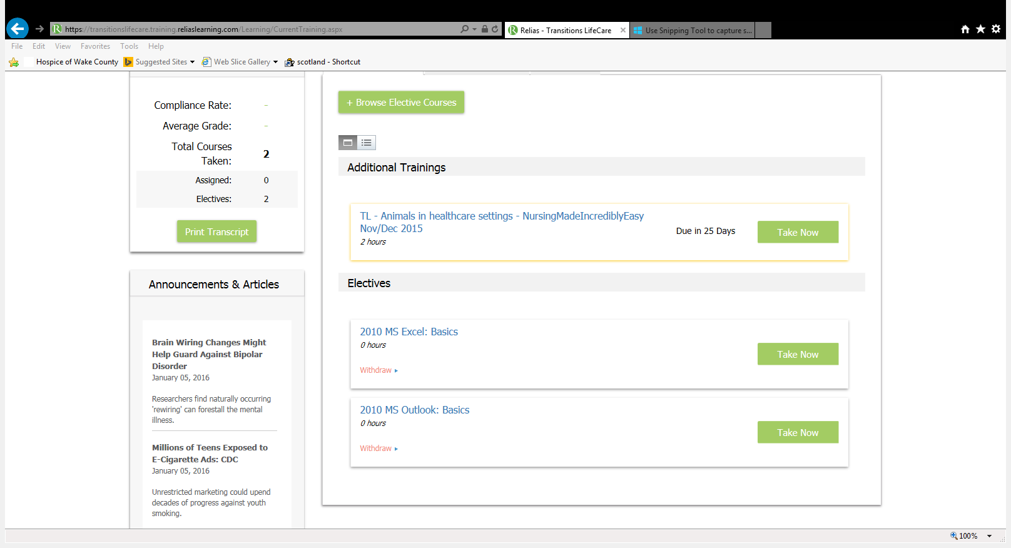

To begin the course simply click on the “Take Now” box

The following is the next screen you will see. It will tell you the numbers of credit hours you will receive, the modules (there may be more than one) and tests (there may be more than one) associated with this course.
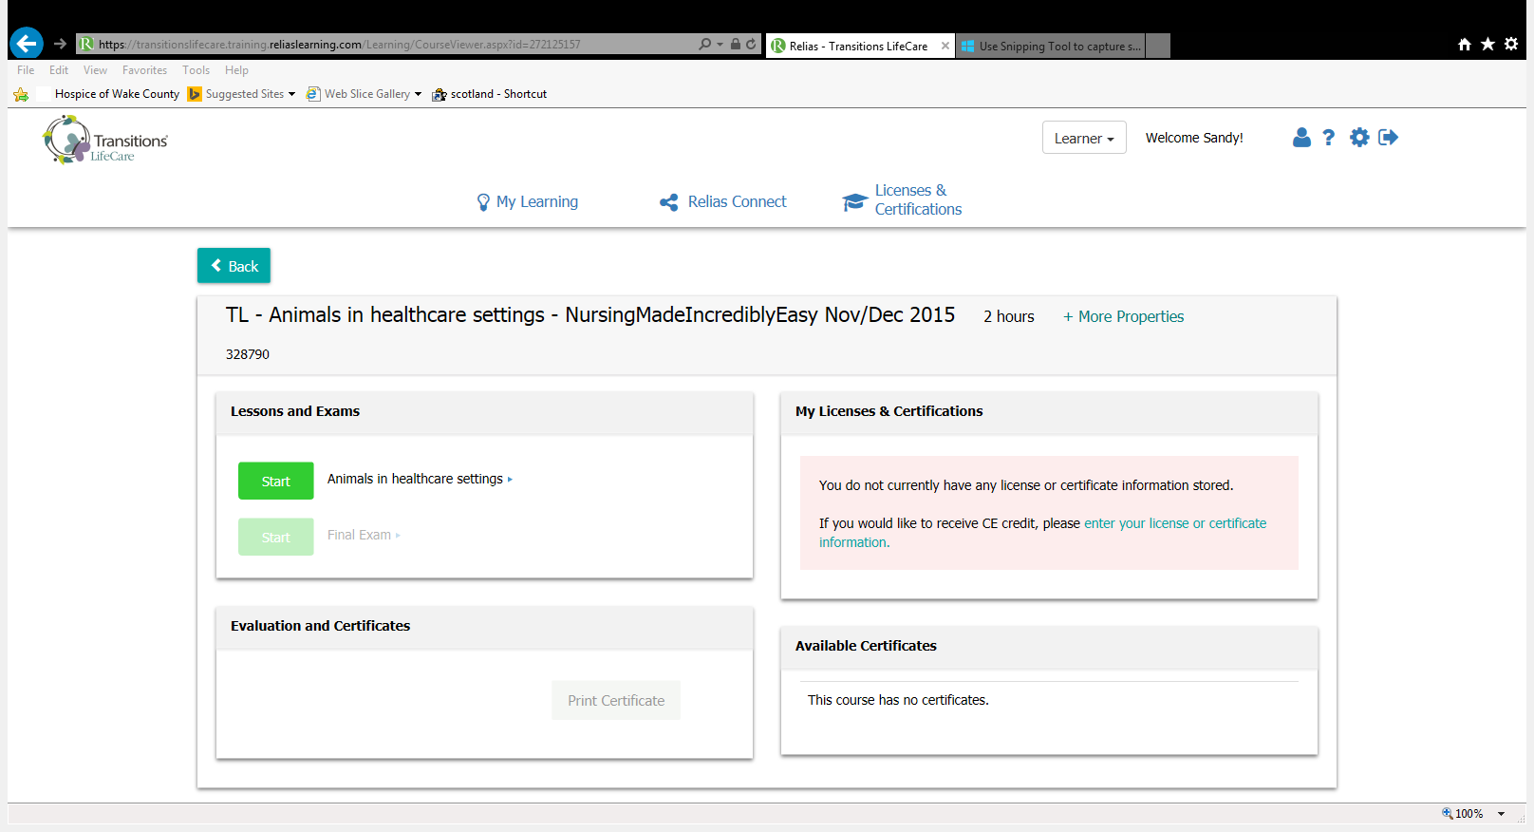

Some courses require you to review the module before taking the test (like this one).
To open the module click on the “Start” box. If you are not required to review the module(s) first the Final Exam “Start” box will be bright and you may go straight to the exam.
Once you click on the “Start” box for the module the system should launch the education module. THE MODULE MAY BE A PDF FILE, A SLIDE SHOW (WITH OR WITHOUT SOUND) OR A VIDEO. For pdf files you can scroll through the document or print it by right clicking in the window and then clicking on Print.
Some computers have pop-up blockers enabled and you may see the following screen. If so click on “Relaunch” and the program should appear.
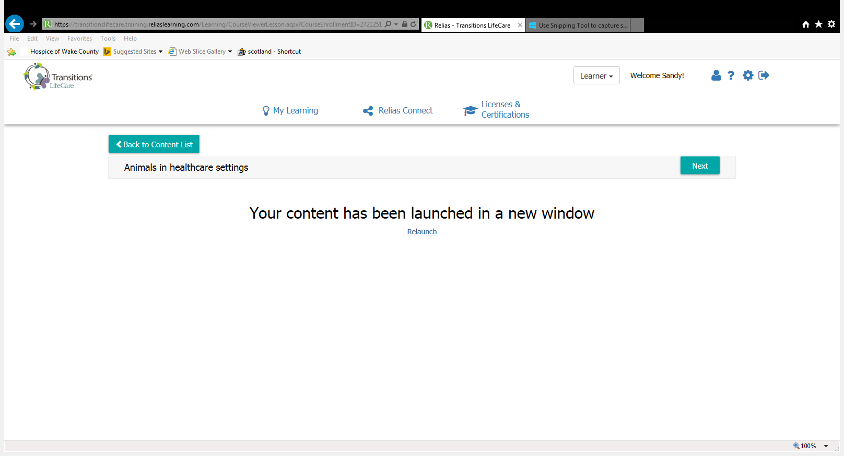
You should see this screen as well when you finish the education modules to go to the test click on the “Back to Content List” box or click on the “Next” box
To launch the test. Click on the “Start” Box next to Final Exam.

NOTE: for both the Education Modules and the Exams you may stop at any time, exit the system and then restart where you left off. For the exams you must press the “Save” box at the bottom of the page before you exit in order for the system to save your answer and return you to your progress within the exam.

To self-enroll in one of the available courses:
Return to the My Learning screen and click on “Browse Elective Courses”
There are more than 400 available courses to select from.
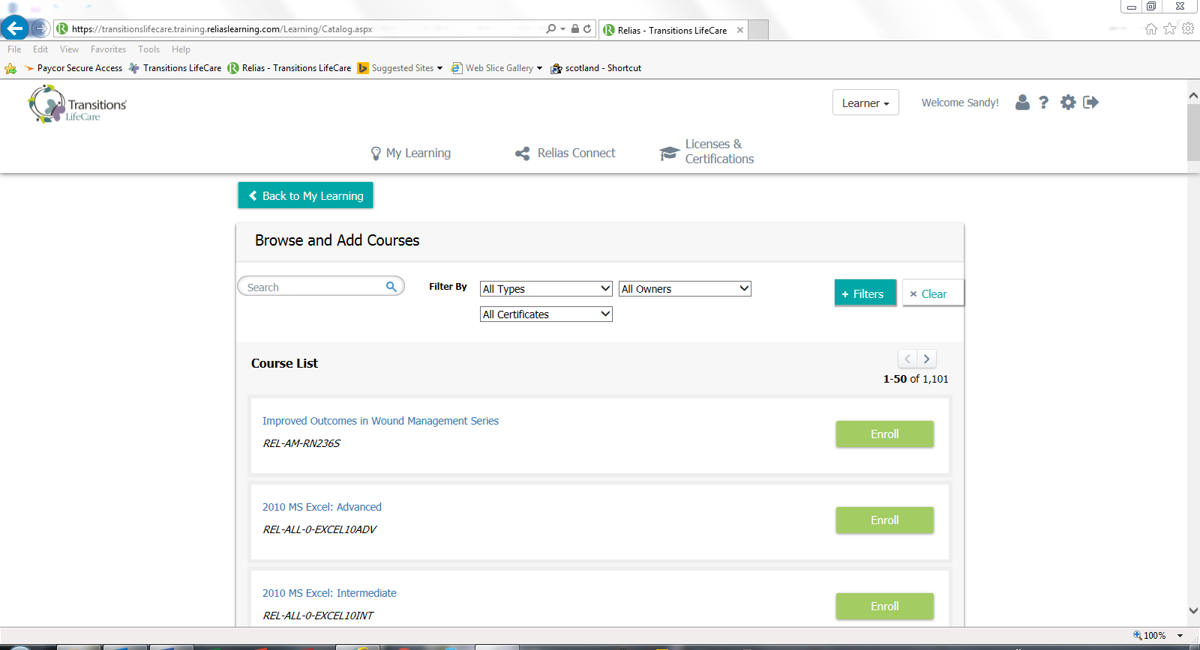
You are able to filter the courses by typing in a key word in the search box.
To see more information about the course; such as a description; the number of hours credit; if it is eligible for certification credit; if it is a video, sides or text document etc. you can click on the title of the course.
Once you have decided to take the course click on the “Enroll” box. The course will now show up on your home screen under My Learning / Current Learning. This may take a few minutes to update.

Your Education Record:
You can monitor you CEU education hours from your home page.
You can print your transcript from this location or you can go to the Transcript tab to view your transcript and print any available certificates.

